**IVAN- Imperial**

**Admin Update: Needs to be complete before the end of May**

1. This is the information that needs to be part of the admin report. This information is generated by submit a report page. Time stamp, report number, category, address, status, verification, notes, delete. Remove- Incident title and view

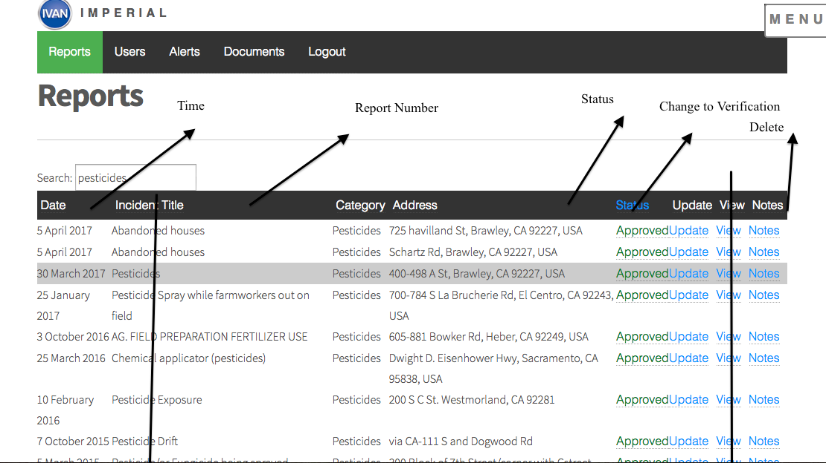

1. Ability to export reports from the website (download as an excel spreadsheet)- (Very Important)

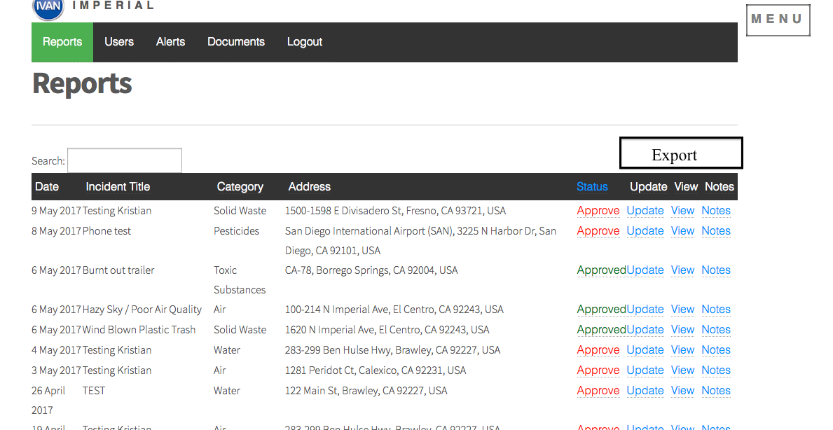

1. Needs to change how the admin search through the reports. The image below is an example of another website: (VERY IMPORTANT)

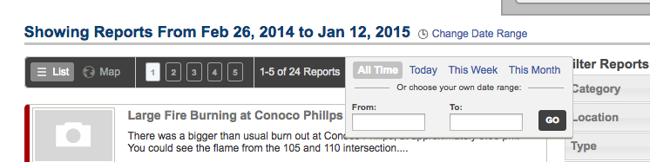

1. Move the status of the report to the top box to the top. (VERY IMPORTANT)

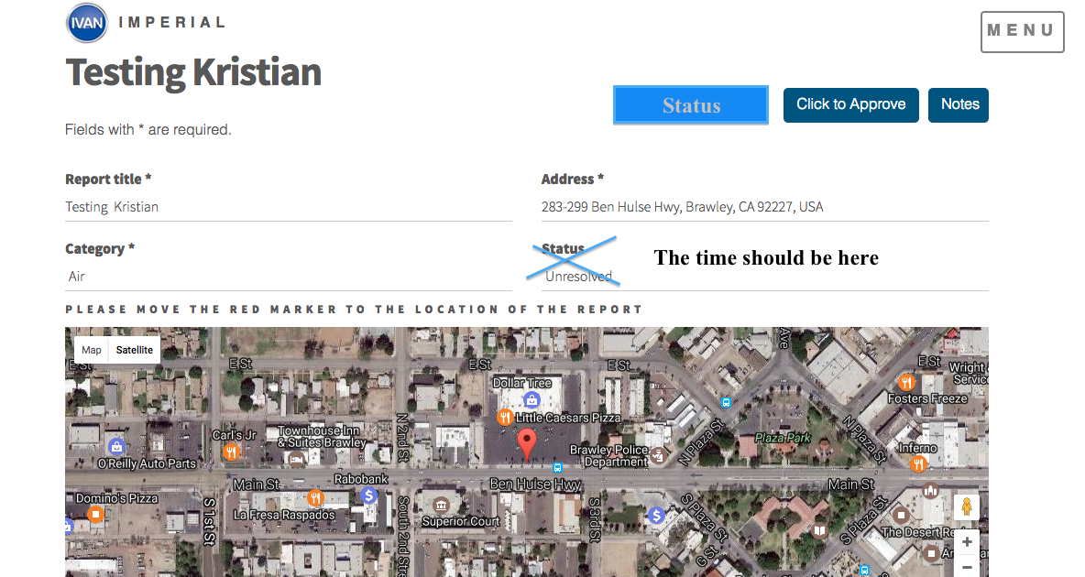

1. Documents are not loading correctly – We need to be able to upload more types of documents, not just pdfs.

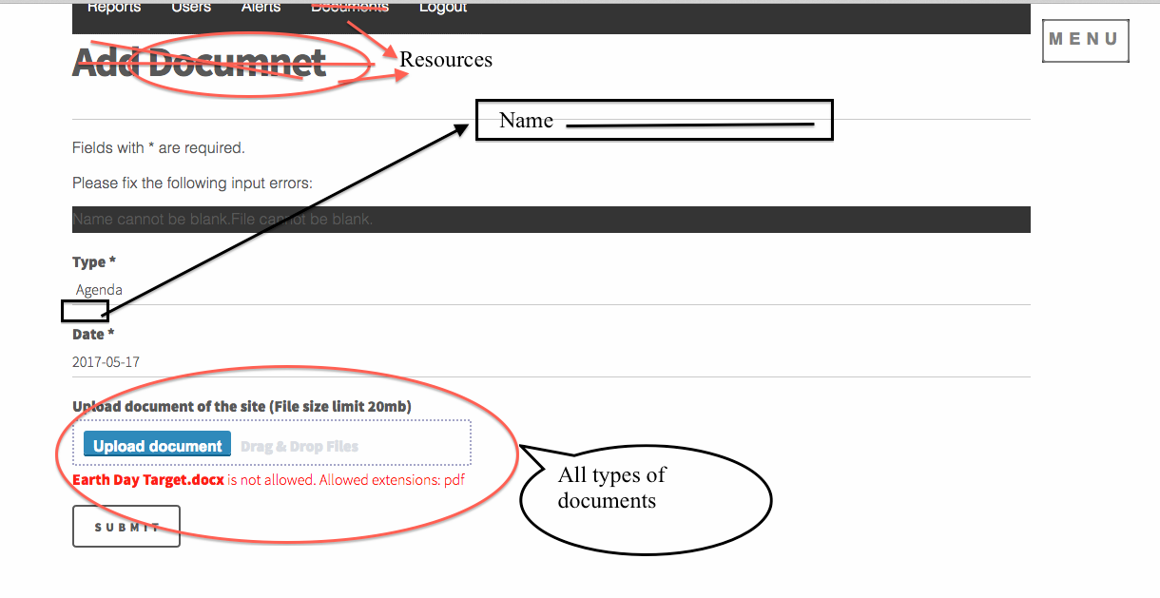

1. The website layout has to be the same for each tab. It should look like Agenda.

